FastAPI assignment
--Dikshitha Modi


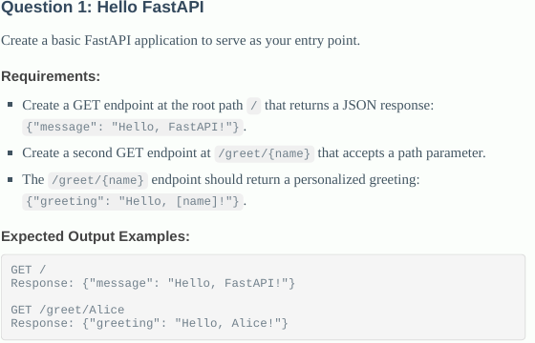

Code:
from fastapi import FastAPI

app=FastAPI()

@app.get("/")
def message():
return {"message": "Hello, FastAPI!"}

@app.get("/greet/{name}")
def get_name(name:str):
return {"greeting":f"Hello, {name}!"}

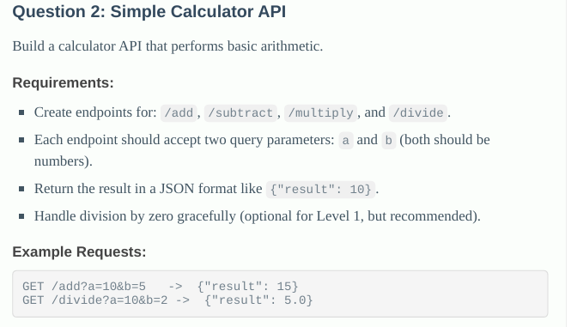

Code:
from fastapi import FastAPI

app=FastAPI()

#http://127.0.0.1:8000/add?a=10&b=5
@app.get('/add')
def add(a:int,b:int):
return {"result": a + b}

@app.get('/subract')
def subract(a:int,b:int):
return {"result": a - b}

@app.get('/multiply')
def multiplication(a:int,b:int):
return {"result": a * b}

@app.get('/divide')
def division(a:int,b:int):
if b == 0:
return {"error": "Division by zero is not allowed"}
return {"result": a / b}

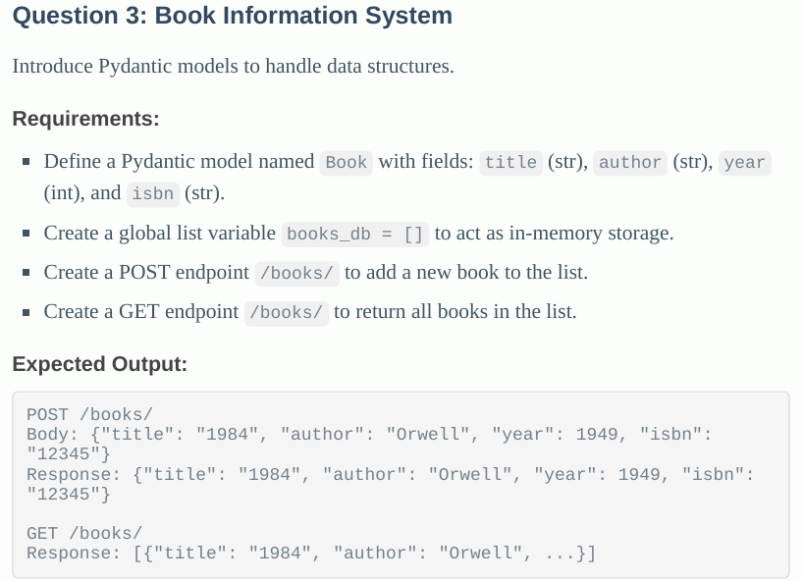

Code:
from fastapi import FastAPI
from pydantic import BaseModel

app=FastAPI()
books_db=[]

class Book(BaseModel):
title:str
author:str
year:int
isbn:str

@app.post("/books/")
def add_books(book:Book):
books_db.append(book)
return book

@app.get("/books/")
def show(book:Book):
return books_db

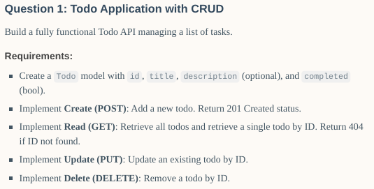

Code:
from fastapi import FastAPI,HTTPException
from typing import Optional,List
from pydantic import BaseModel
app=FastAPI()

class ToDo(BaseModel):
id: int
title: str
description: Optional[str] = None
completed: bool = False

class ToDoCreate(BaseModel):
title: str
description: Optional[str] = None
completed: bool = False

tasks_db: List[ToDo] = []

@app.post("/todos/", status_code=201)
def create_todo(todo: ToDoCreate):
new_id = len(tasks_db) + 1
new_todo = ToDo(id=new_id, **todo.dict())
tasks_db.append(new_todo)
return new_todo

@app.get("/todos/")
def get_all_todos():
return tasks_db

@app.get("/todos/{id}")
def get_todo(id: int):
for todo in tasks_db:
if todo.id == id:
return todo
raise HTTPException(status_code=404, detail="Todo not found")

@app.put("/todos/{id}")
def update_todo(id: int, updated: ToDoCreate):
for index, todo in enumerate(tasks_db):
if todo.id == id:
tasks_db[index] = ToDo(id=id, **updated.dict())
return tasks_db[index]
raise HTTPException(status_code=404, detail="Todo not found")

@app.delete("/todos/{id}")
def delete_todo(id: int):
for index, todo in enumerate(tasks_db):
if todo.id == id:
tasks_db.pop(index)
return {"message": "Todo deleted successfully"}
raise HTTPException(status_code=404, detail="Todo not found")

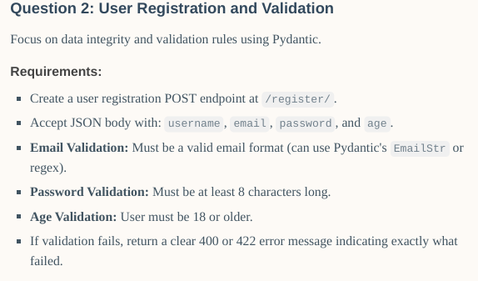

Code:
from fastapi import FastAPI, HTTPException
from pydantic import BaseModel, EmailStr, validator

app = FastAPI()

class UserRegistration(BaseModel):
username: str
email: EmailStr
password: str
age: int

@validator('password')
def password_min_length(cls, v):
if len(v) < 8:
raise ValueError('Password must be at least 8 characters long')
return v

@validator('age')
def age_must_be_adult(cls, v):
if v < 18:
raise ValueError('User must be 18 or older')
return v

@app.post("/register/")
async def register_user(user: UserRegistration):
# Here you would normally save the user to a database
return {"message": "User registered successfully", "user": user.dict()}

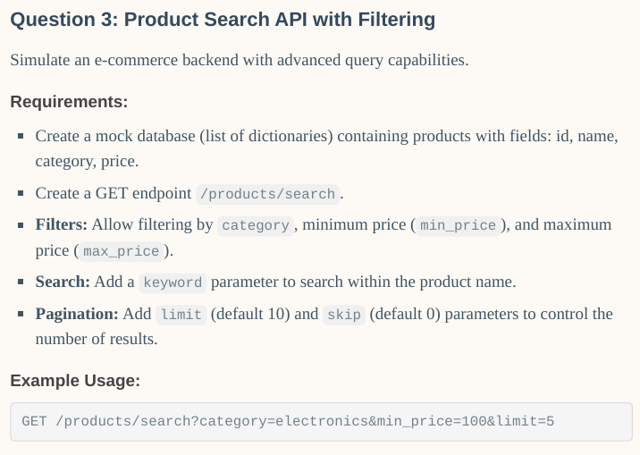

Code:
from typing import Optional, List
from fastapi import FastAPI, Query

app = FastAPI()

# Mock database
products_db = [
{"id": 1, "name": "iPhone 14", "category": "electronics", "price": 999},
{"id": 2, "name": "Samsung Galaxy S23", "category": "electronics", "price": 899},
{"id": 3, "name": "Sony Headphones", "category": "electronics", "price": 199},
{"id": 4, "name": "Leather Wallet", "category": "fashion", "price": 49},
{"id": 5, "name": "Nike Sneakers", "category": "fashion", "price": 120},
{"id": 6, "name": "Organic Coffee", "category": "groceries", "price": 15},
{"id": 7, "name": "MacBook Pro", "category": "electronics", "price": 1999},
{"id": 8, "name": "LED Desk Lamp", "category": "home", "price": 35},
{"id": 9, "name": "Yoga Mat", "category": "fitness", "price": 25},
{"id": 10, "name": "Blender", "category": "home", "price": 60},
{"id": 11, "name": "Fitbit Charge 5", "category": "fitness", "price": 150},
{"id": 12, "name": "Dell XPS 13", "category": "electronics", "price": 1200},
]

@app.get("/products/search")
def search_products(
category: Optional[str] = Query(None, description="Filter by category"),
min_price: Optional[float] = Query(None, description="Minimum price"),
max_price: Optional[float] = Query(None, description="Maximum price"),
keyword: Optional[str] = Query(None, description="Search keyword in product name"),
limit: int = Query(10, ge=1, description="Number of results to return"),
skip: int = Query(0, ge=0, description="Number of results to skip"),
) -> List[dict]:
# Start with all products
results = products_db

# Apply category filter
if category:
results = [p for p in results if p["category"].lower() == category.lower()]

# Apply minimum price filter
if min_price is not None:
results = [p for p in results if p["price"] >= min_price]

# Apply maximum price filter
if max_price is not None:
results = [p for p in results if p["price"] <= max_price]

# Apply keyword search
if keyword:
results = [p for p in results if keyword.lower() in p["name"].lower()]

# Apply pagination
results = results[skip : skip + limit]
return results

